**Open Software Project**

**경영학과 1517034 정성원**

**Assignment 2**

**1. PDF / CDF Generation**

**A. Code**

**B. Result**

-Image(grayscale)

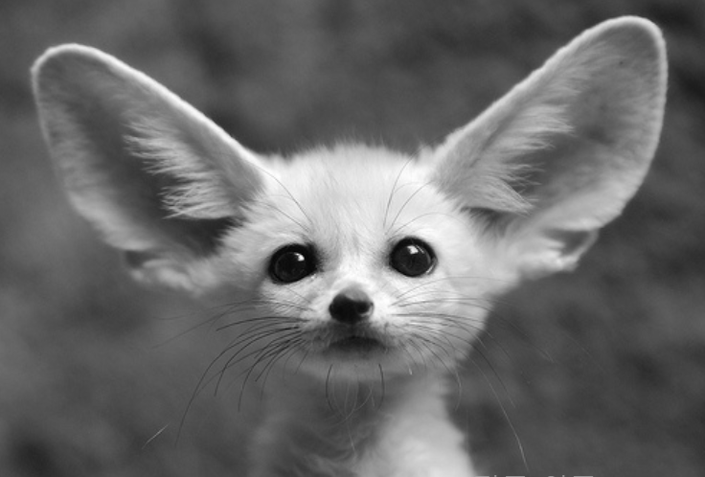

-PDF

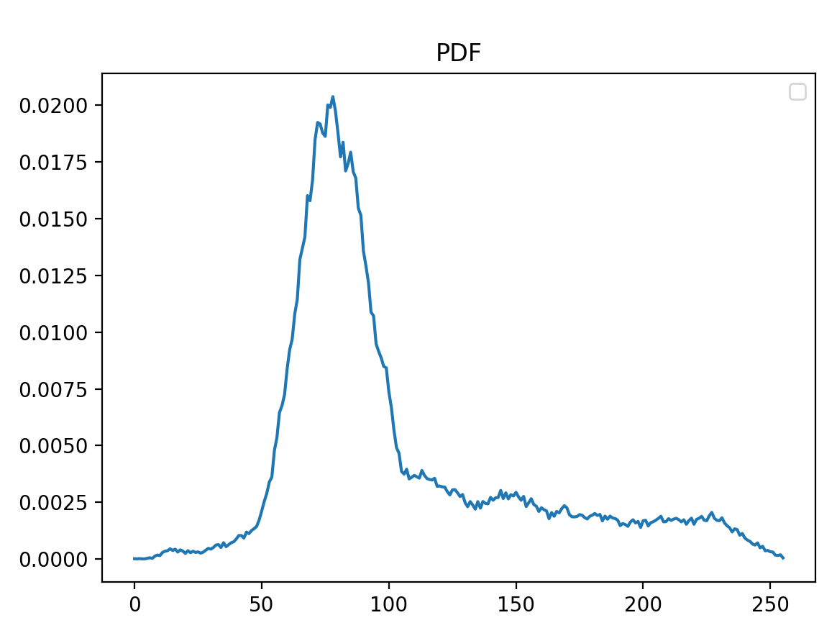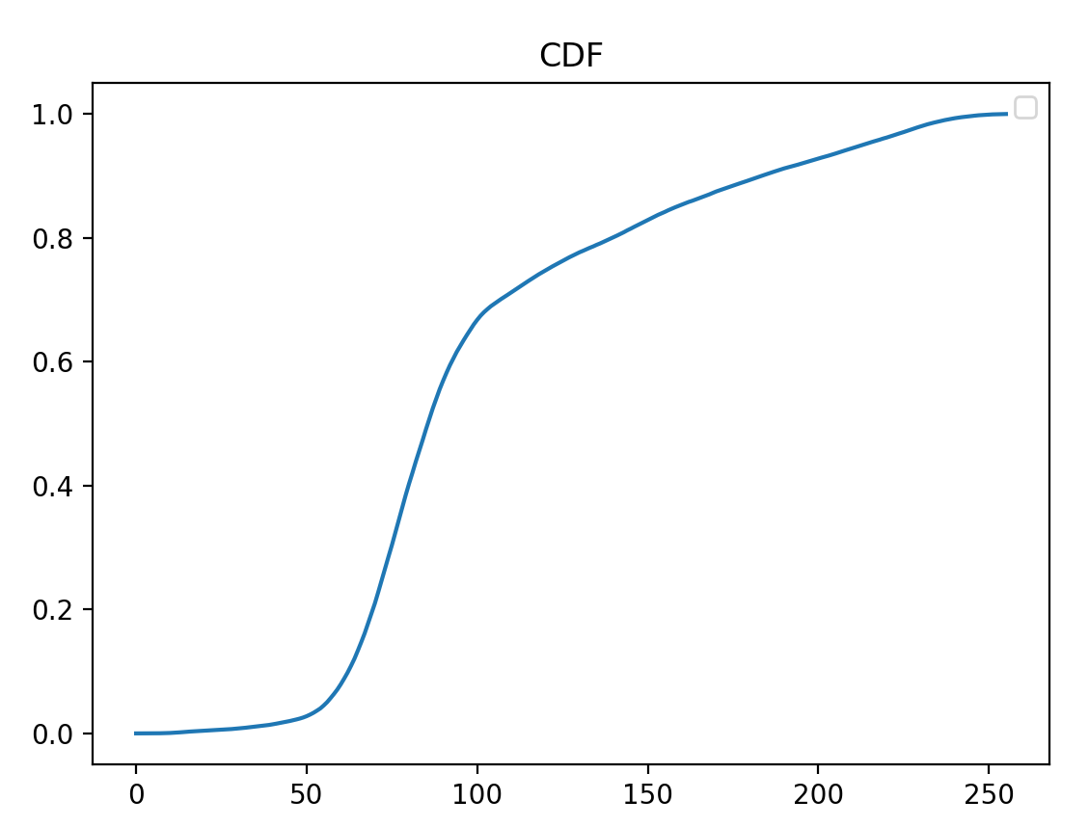

**2. Histogram Stretching**

**A. Code**

**B. Result**

-Original Image / Histogram

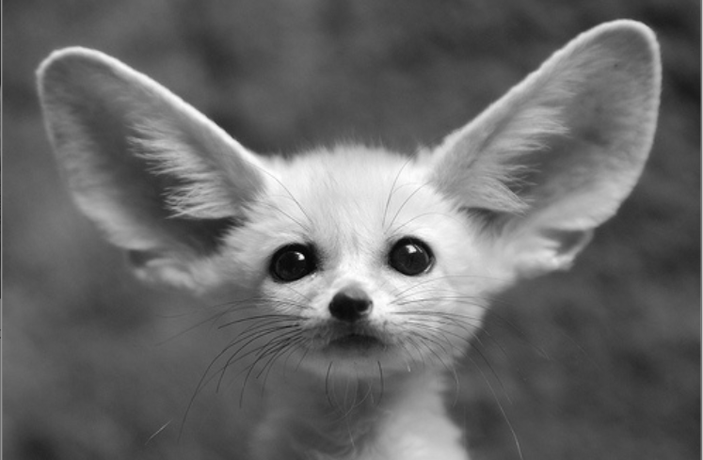

-Stretched image / Histogram

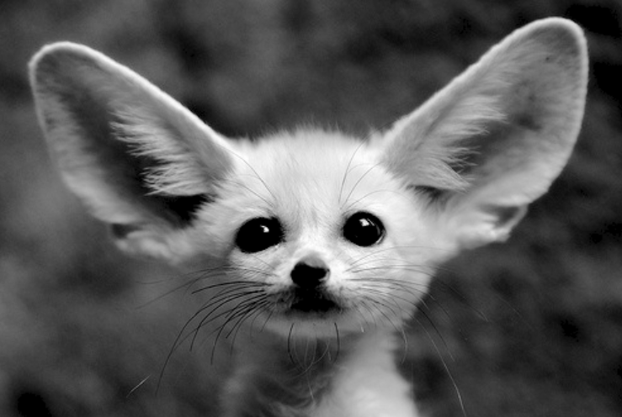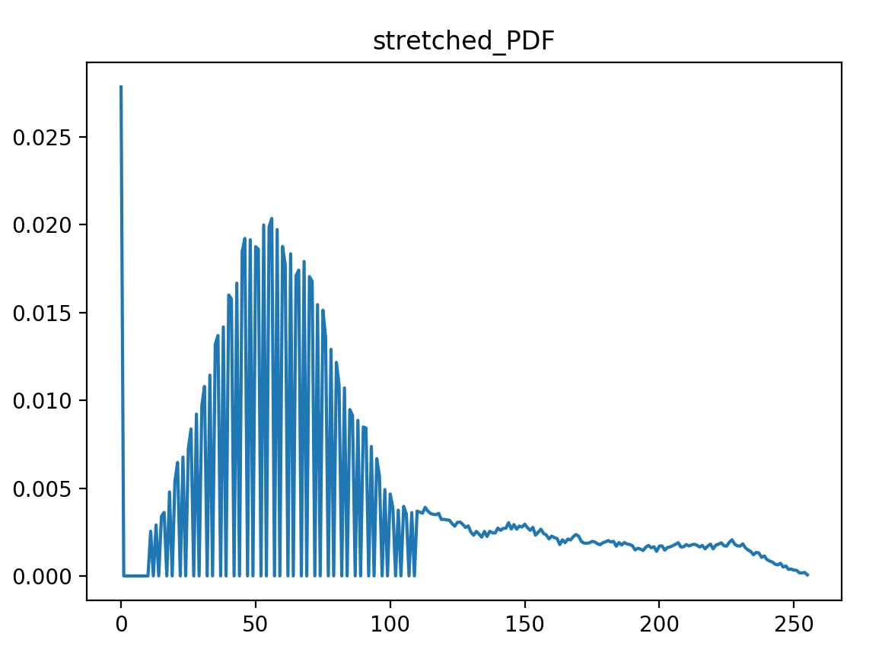

-transfer function

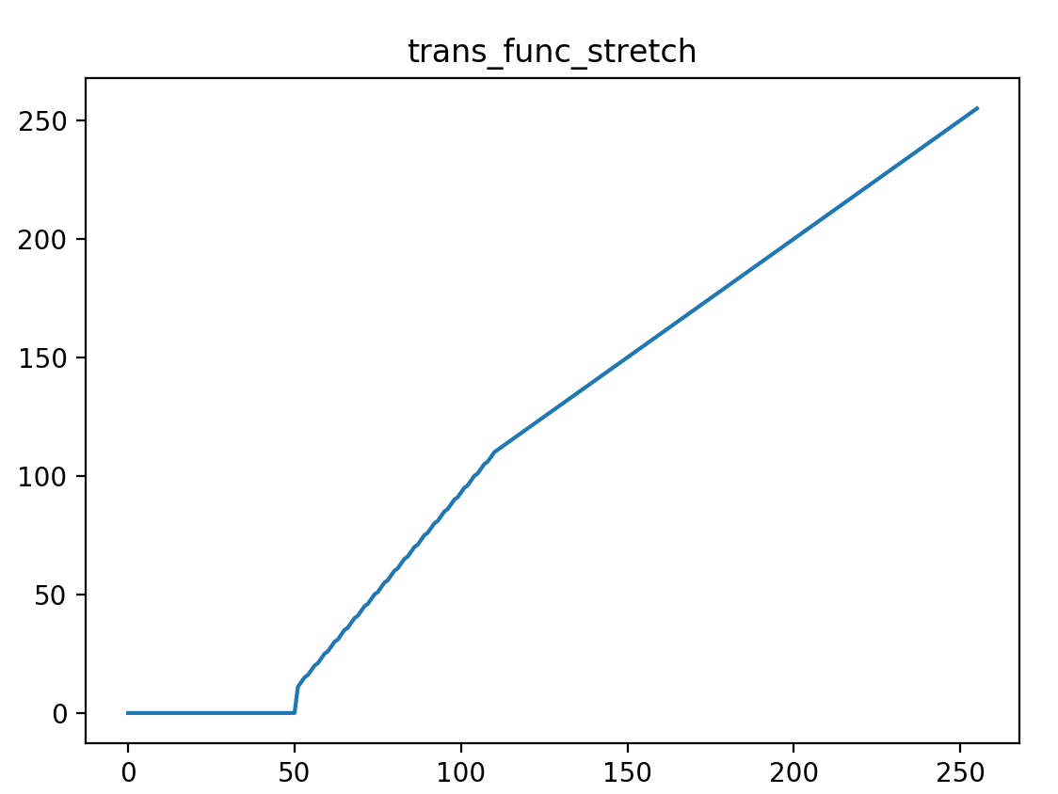

**3. Histogram Equalization**

**1) Grayscale Image**

**A. Code**

// histogram equalization

void hist_eq(Mat &input, Mat &equalized, G *trans_func, float *CDF) {

// compute transfer function

for (int i = 0; i < L; i++)

trans_func[i] = (G)((L - 1) * CDF[i]);

// perform the transfer function

for (int i = 0; i < input.rows; i++)

for (int j = 0; j < input.cols; j++)

equalized.at<G>(i, j) = trans_func[input.at<G>(i, j)];

}

**B. Result**

-Original Image / Histogram



-Output image / Histogram

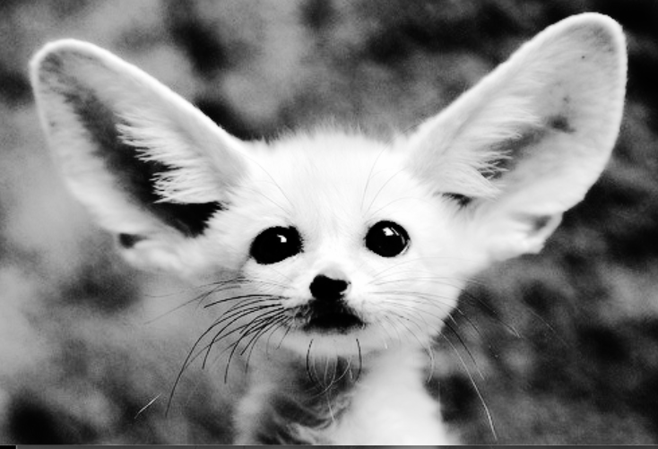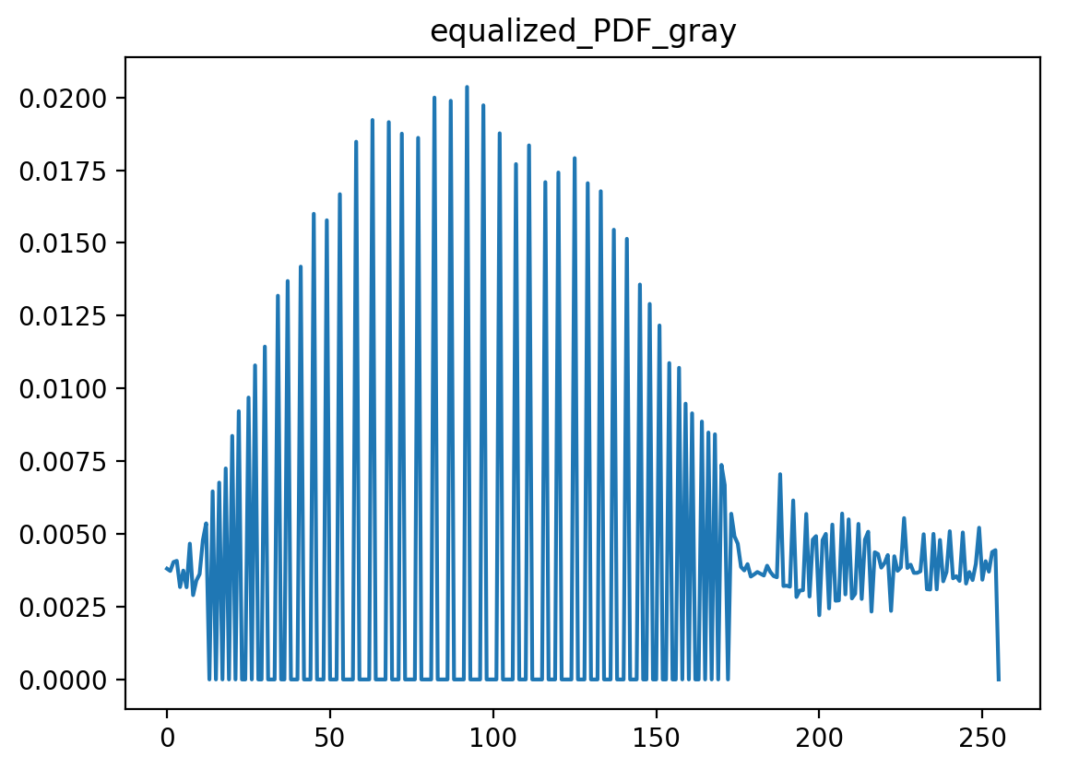

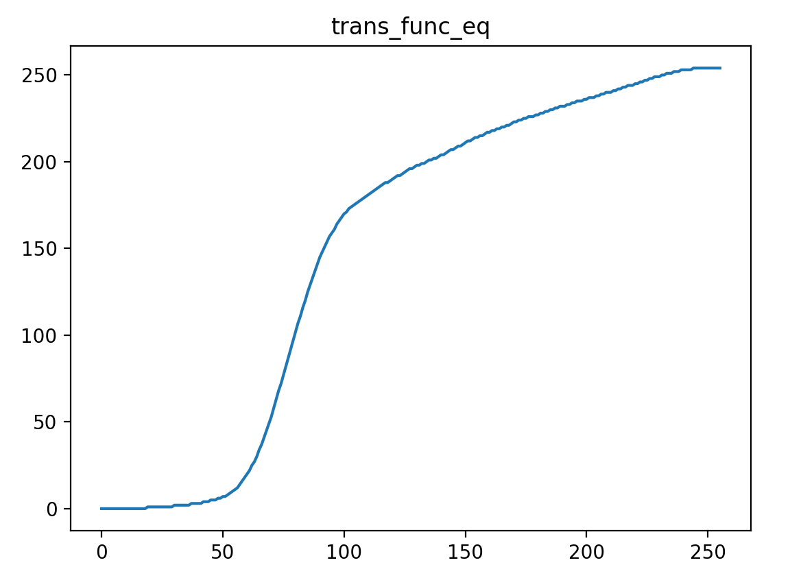

**2) RGB**

**A. Code**

// histogram equalization on 3 channel image

void hist_eq_Color(Mat &input, Mat &equalized, G(*trans_func)[3], float **CDF) {

// compute transfer function

for (int i = 0; i < L; i++)

for(int k = 0; k < 3 ; k++)

trans_func[i][k] = (G)((L - 1) * CDF[i][k]);

// perform the transfer function

for (int i = 0; i < input.rows; i++)

for (int j = 0; j < input.cols; j++)

for (int k =0; k < 3; k++)

equalized.at<C>(i, j)[k] = trans_func[input.at<C>(i, j)[k]][k];

}

**B. Result**

-Original image / Histogram

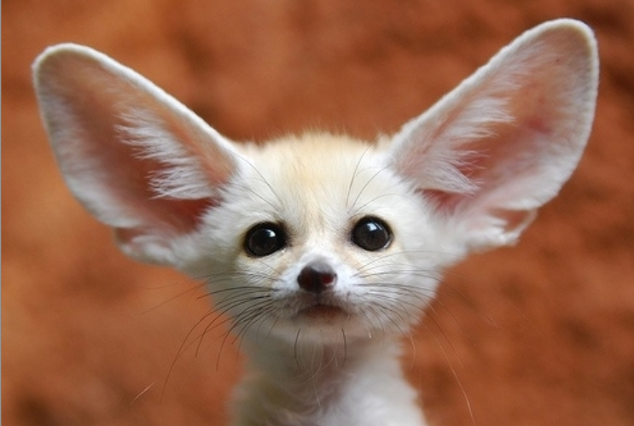

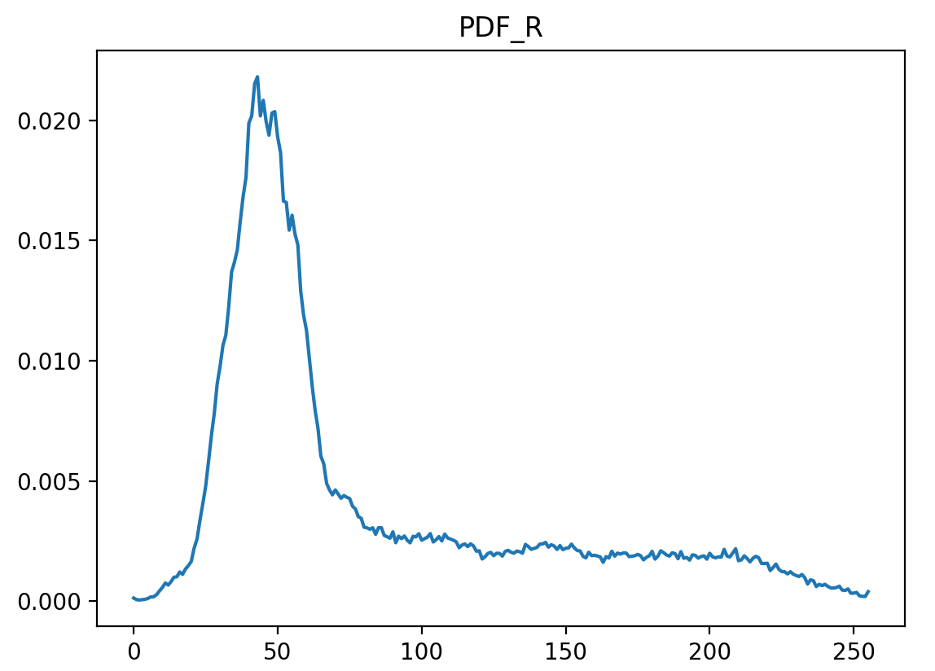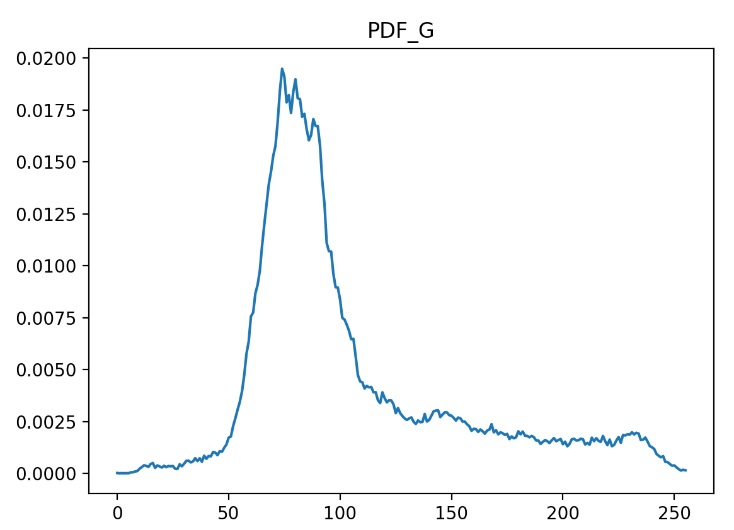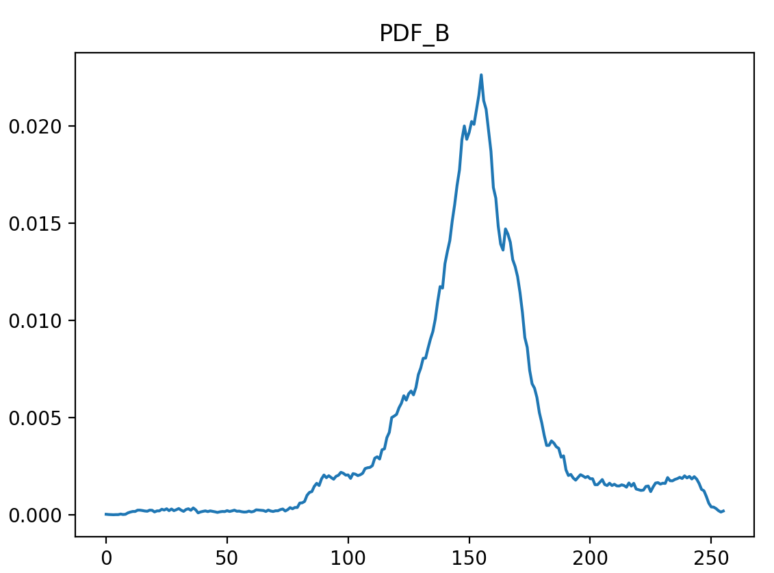

-Output image / Histogram

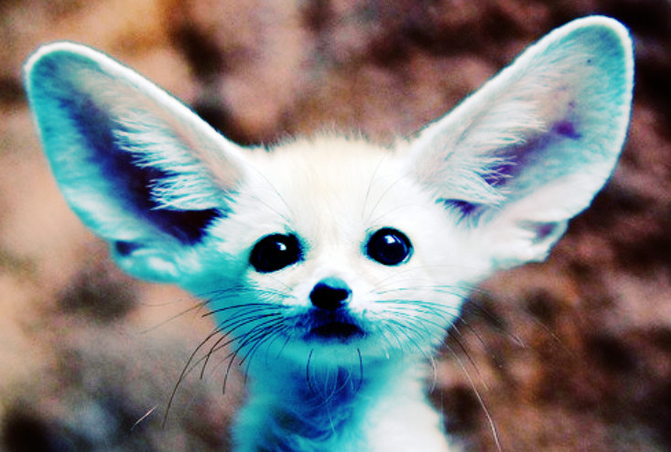

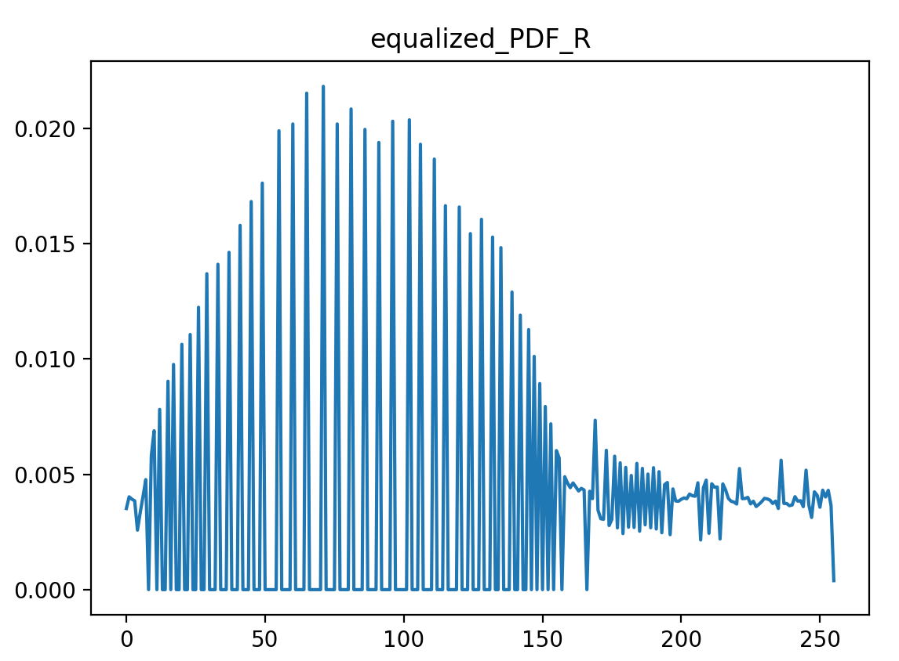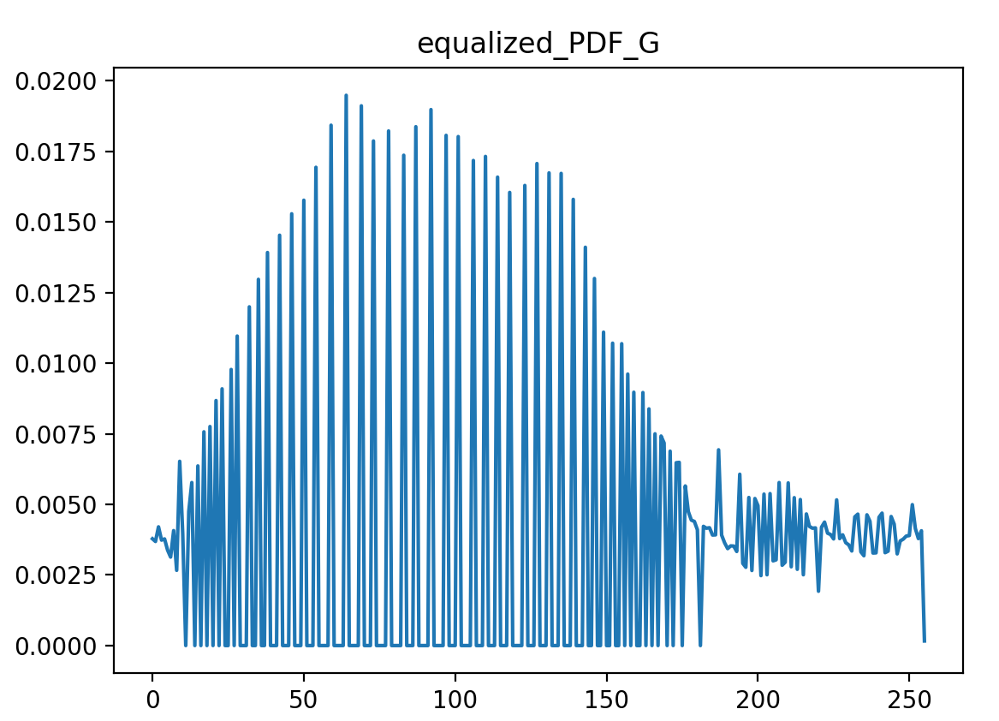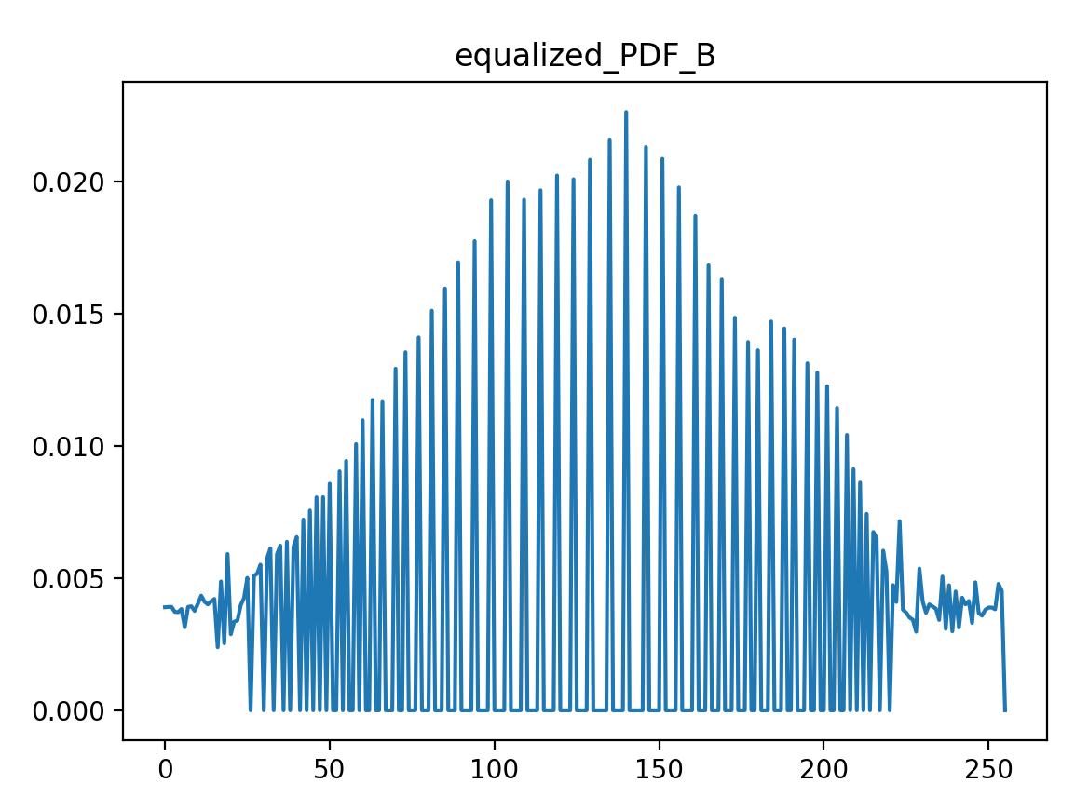

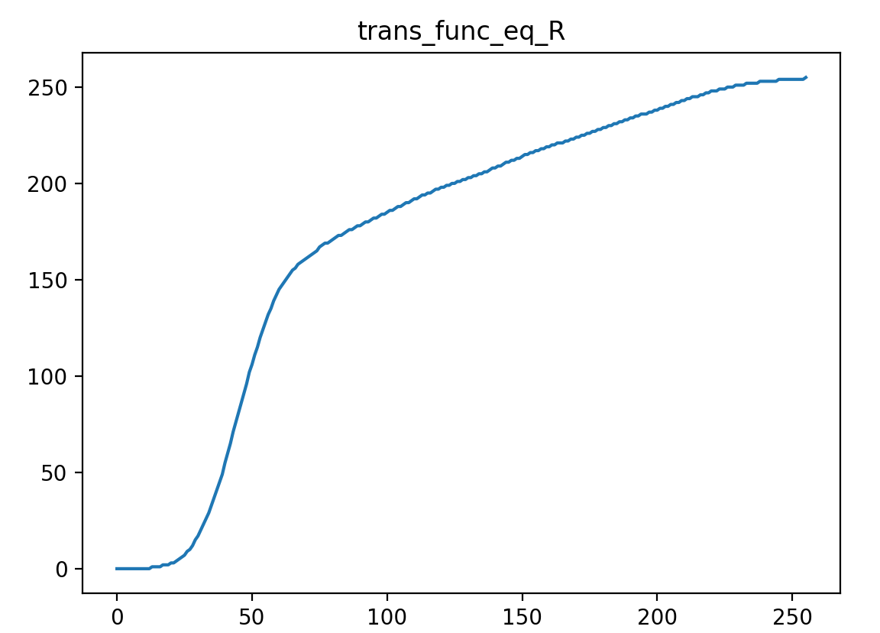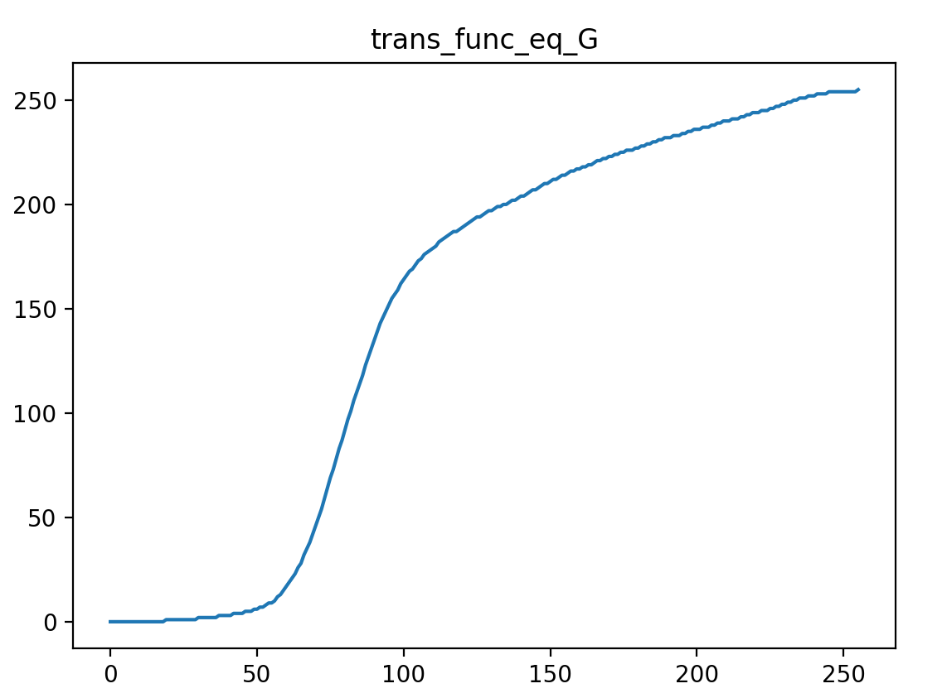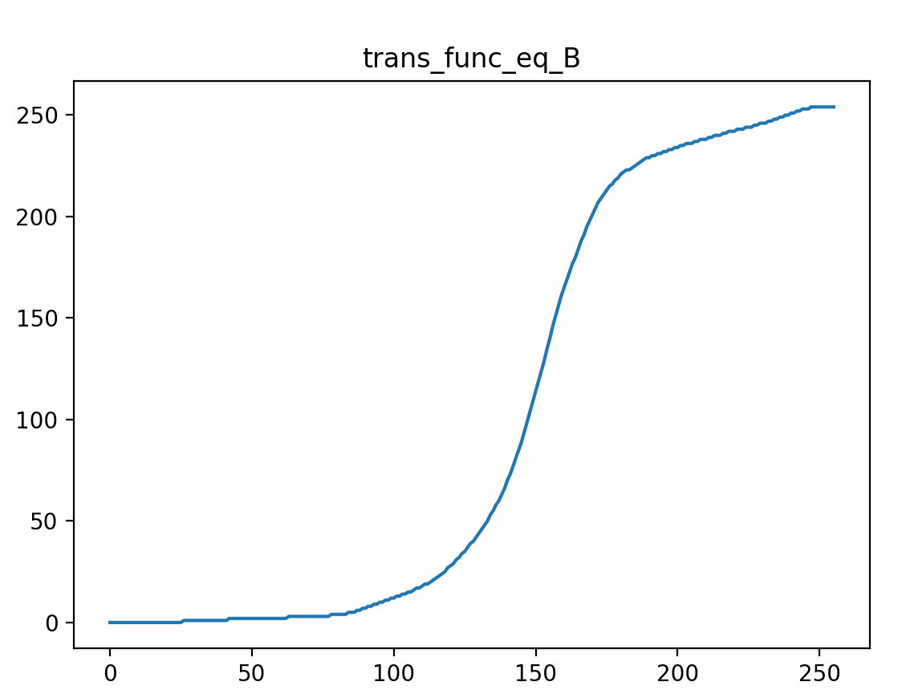

**3) YUV**

**A. Code**

int main() {

Mat input = imread("input.jpg", CV_LOAD_IMAGE_COLOR);

Mat equalized_YUV;

cvtColor(input, equalized_YUV, CV_RGB2YUV); // RGB -> YUV

// split each channel(Y, U, V)

Mat channels[3];

split(equalized_YUV, channels);

Mat Y = channels[0]; // U = channels[1], V = channels[2]

// PDF or transfer function txt files

FILE *f_PDF_R, *f_PDF_G, *f_PDF_B;

FILE *f_equalized_PDF_YUV_R, *f_equalized_PDF_YUV_G, *f_equalized_PDF_YUV_B;

FILE *f_trans_func_eq_YUV;

float **PDF_RGB = cal_PDF_RGB(input); // PDF of Input image(RGB) : [L][3]

float *CDF_YUV = cal_CDF(Y); // CDF of Y channel image

fopen_s(&f_PDF_R, "PDF_R.txt", "w+"); fopen_s(&f_PDF_G, "PDF_G.txt", "w+"); fopen_s(&f_PDF_B, "PDF_B.txt", "w+");

fopen_s(&f_equalized_PDF_YUV_R, "equalized_PDF_YUV_R.txt", "w+"); fopen_s(&f_equalized_PDF_YUV_G, "equalized_PDF_YUV_G.txt", "w+"); fopen_s(&f_equalized_PDF_YUV_B, "equalized_PDF_YUV_B.txt", "w+");

fopen_s(&f_trans_func_eq_YUV, "trans_func_eq_YUV.txt", "w+");

G trans_func_eq_YUV[L] = { 0 }; // transfer function

// histogram equalization on Y channel

hist_eq(Y, Y, trans_func_eq_YUV, CDF_YUV);

// merge Y, U, V channels

merge(channels, 3, equalized_YUV);

// YUV -> RGB (use "CV_YUV2RGB" flag)

cvtColor(equalized_YUV, equalized_YUV, CV_YUV2RGB);

// equalized PDF (YUV)

float **equalized_PDF_YUV = cal_PDF_RGB(equalized_YUV);

//write files

for (int i = 0; i < L; i++) {

// write PDF of original image

fprintf(f_PDF_R, "%d\t%f\n", i, PDF_RGB[i][0]); fprintf(f_PDF_G, "%d\t%f\n", i, PDF_RGB[i][1]); fprintf(f_PDF_B, "%d\t%f\n", i, PDF_RGB[i][2]);

// write PDF of output image

fprintf(f_equalized_PDF_YUV_R, "%d\t%f\n", i, equalized_PDF_YUV[i][0]); fprintf(f_equalized_PDF_YUV_G, "%d\t%f\n", i, equalized_PDF_YUV[i][1]); fprintf(f_equalized_PDF_YUV_B, "%d\t%f\n", i, equalized_PDF_YUV[i][2]);

// write transfer functions

fprintf(f_trans_func_eq_YUV, "%d\t%d\n", i, trans_func_eq_YUV[i]);

}

// memory release

free(PDF_RGB);

free(CDF_YUV);

fclose(f_PDF_R); fclose(f_PDF_G); fclose(f_PDF_B);

fclose(f_equalized_PDF_YUV_R); fclose(f_equalized_PDF_YUV_G); fclose(f_equalized_PDF_YUV_B);

fclose(f_trans_func_eq_YUV);

////////////////////// Show each image ///////////////////////

namedWindow("RGB", WINDOW_AUTOSIZE);

imshow("RGB", input);

namedWindow("Equalized_YUV", WINDOW_AUTOSIZE);

imshow("Equalized_YUV", equalized_YUV);

//////////////////////////////////////////////////////////////

waitKey(0);

return 0;

}

// histogram equalization

void hist_eq(Mat &input, Mat &equalized, G *trans_func, float *CDF) {

// compute transfer function

for (int i = 0; i < L; i++)

trans_func[i] = (G)((L - 1) * CDF[i]);

// perform the transfer function

for (int i = 0; i < input.rows; i++)

for (int j = 0; j < input.cols; j++)

equalized.at<G>(i, j) = trans_func[input.at<G>(i, j)];

}

**B. Result**

-Original Image / Histogram

3-2)-B와 동일

-Output image / Histogram

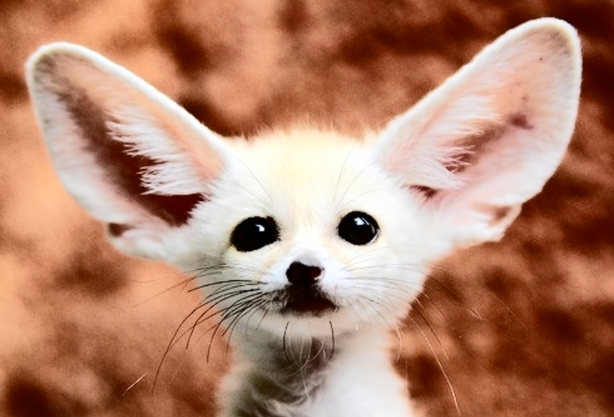

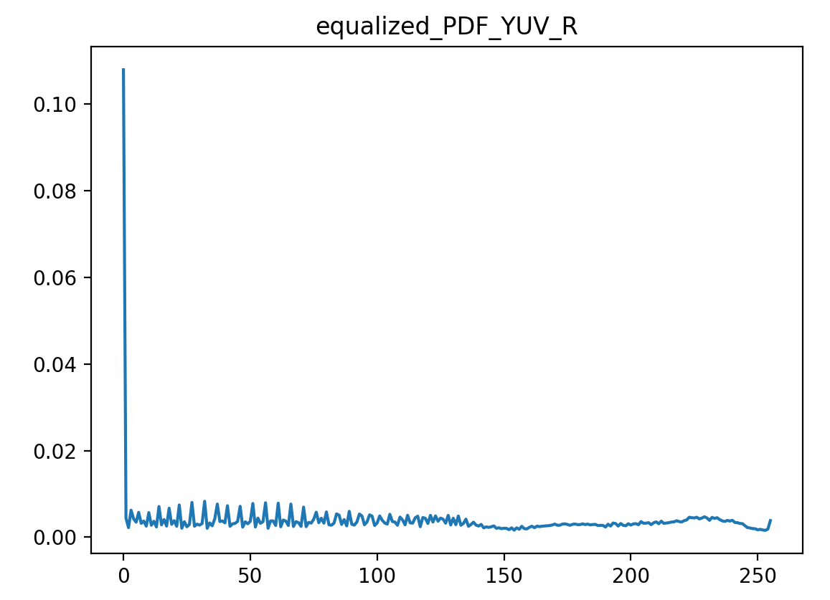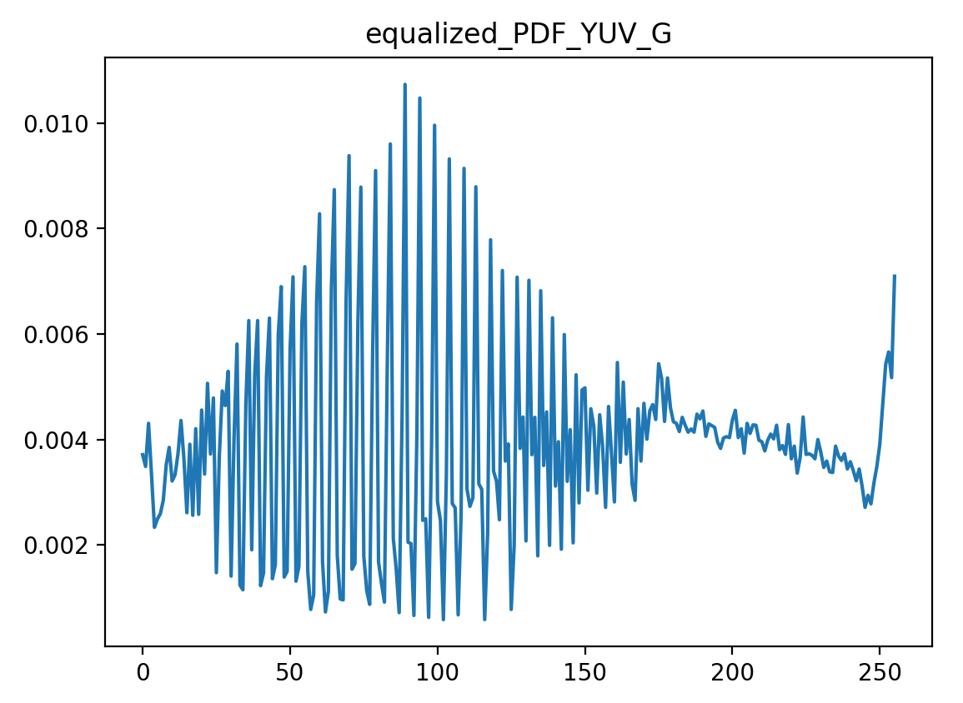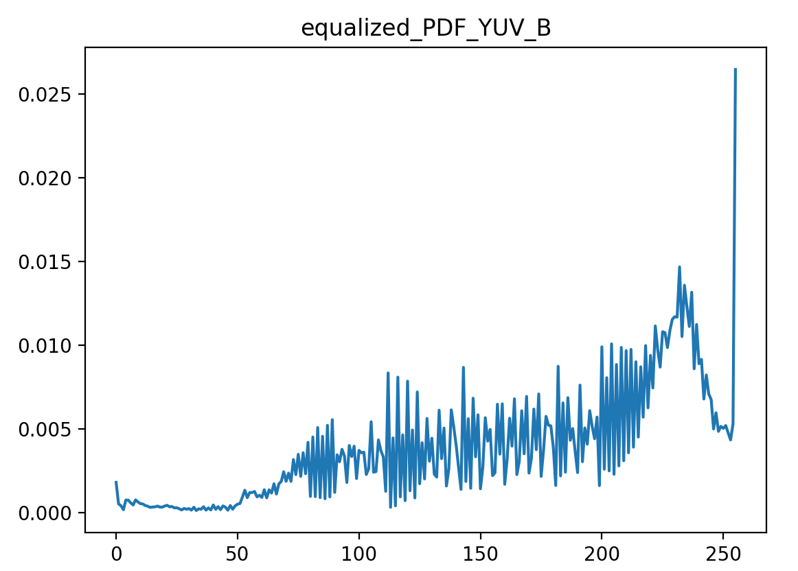

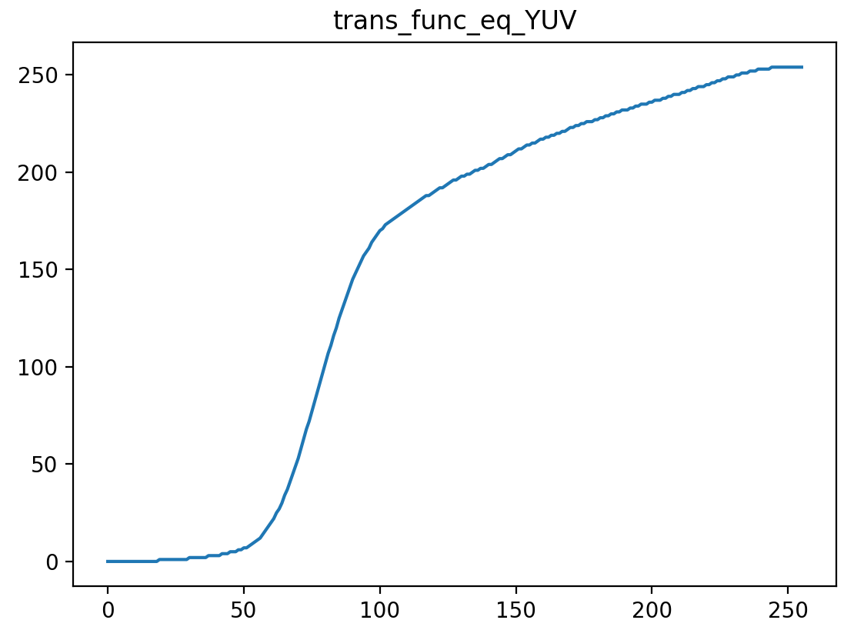

**4. Histogram Matching**

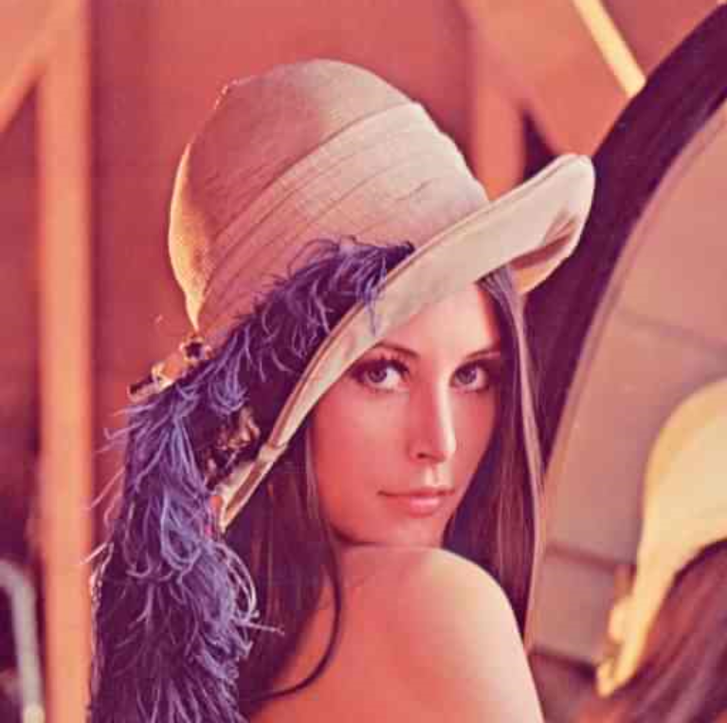**-**ref.jpg를 reference image로 사용함

**1) Grayscale Image**

**A. Code**

#include "hist_func.h"

#include <iostream>

using namespace std;

void hist_eq(Mat &input, Mat &equalized, G *trans_func, float *CDF);

void func_inverse(G *trans_func, G *inverse_func);

int main() {

/*

Input: Original Image, Reference Image

Output:

-histogram-matched image

-1 transfer function(txt file)

-1 histogram of the original image(txt file)

-1 histogram of the ouput image(txt file)

*/

Mat input = imread("input.jpg", CV_LOAD_IMAGE_COLOR);

Mat input_gray;

Mat ref = imread("ref.jpg", CV_LOAD_IMAGE_COLOR);

Mat ref_gray;

cvtColor(input, input_gray, CV_RGB2GRAY); // Convert RGB to Gray

cvtColor(ref, ref_gray, CV_RGB2GRAY); // Convert RGB to Gray

Mat equalized = input_gray.clone();

Mat equalized_ref = ref_gray.clone();

Mat matched = input_gray.clone();

//PDF or Transfer function txt

FILE *f_PDF;

//FILE *f_ref_PDF_gray;

FILE *f_matched_PDF_gray;

FILE *f_trans_func_match_gray;

fopen_s(&f_PDF, "PDF.txt", "w+");

//fopen_s(&f_ref_PDF_gray, "ref_PDF.txt", "w+");

fopen_s(&f_matched_PDF_gray, "matched_PDF_gray.txt", "w+");

fopen_s(&f_trans_func_match_gray, "trans_func_match_gray.txt", "w+");

//1. Compute the transfer functions s = T(r) for histogram equalization of an input image, and perform histogram equalization

float *PDF_input = cal_PDF(input_gray); // PDF of Input image(Grayscale) : [L]

float *CDF_input = cal_CDF(input_gray); // CDF of Input image(Grayscale) : [L]

G Tr[L] = { 0 }; // transfer function

hist_eq(input_gray, equalized, Tr, CDF_input); // histogram equalization on grayscale image

//2. Compute the transfer functions s = G(z) for histogram equalization of the specified PDF

float *PDF_ref = cal_PDF(ref_gray); // equalized PDF (grayscale)

float *CDF_ref = cal_CDF(ref_gray);

G Gz[L] = { 0 }; // transfer function

hist_eq(ref_gray, equalized_ref, Gz, CDF_ref);

float *z = cal_PDF(equalized_ref);

//3. Apply the intensity mapping from r to z

G inverseGz[L] = { 0 };

func_inverse(Gz, inverseGz);

// perform the transfer function

for (int i = 0; i < input.rows; i++)

for (int j = 0; j < input.cols; j++)

matched.at<G>(i, j) = inverseGz[Tr[input_gray.at<G>(i, j)]];

float *matched_PDF_gray = cal_PDF(matched);

//write files

for (int i = 0; i < L; i++) {

// write PDF

fprintf(f_PDF, "%d\t%f\n", i, PDF_input[i]);

//fprintf(f_ref_PDF_gray, "%d\t%f\n", i, PDF_ref[i]);

fprintf(f_matched_PDF_gray, "%d\t%f\n", i, matched_PDF_gray[i]);

// write transfer functions

fprintf(f_trans_func_match_gray, "%d\t%d\n", i, inverseGz[Tr[i]]);

}

// memory release

fclose(f_PDF);

//fclose(f_ref_PDF);

fclose(f_matched_PDF_gray);

fclose(f_trans_func_match_gray);

////////////////////// Show each image ///////////////////////

namedWindow("Grayscale", WINDOW_AUTOSIZE);

imshow("Grayscale", input_gray);

namedWindow("Matched", WINDOW_AUTOSIZE);

imshow("Matched", matched);

//////////////////////////////////////////////////////////////

waitKey(0);

return 0;

}

// histogram equalization

void hist_eq(Mat &input, Mat &equalized, G *trans_func, float *CDF) {

// compute transfer function

for (int i = 0; i < L; i++) {

trans_func[i] = (G)((L - 1) * CDF[i]);

}

// perform the transfer function

for (int i = 0; i < input.rows; i++)

for (int j = 0; j < input.cols; j++)

equalized.at<G>(i, j) = trans_func[input.at<G>(i, j)];

}

//get inverse function G-1

void func_inverse(G *trans_func, G *inverse_func){

/* Return z = G-1(s) */

bool checked[L] = { 0 };

for (int i = 0; i < L; i++) {

if (checked[trans_func[i]])

continue;

inverse_func[trans_func[i]] = (G)i;

checked[trans_func[i]] = 1;

}

for (int i = 0; i < L; i++)

if (!checked[i])

inverse_func[i] = (G)inverse_func[i - 1];

}

**B. Result**

**-Original Image / Histogram**

1-B 와 동일

**-Output image / Histogram**

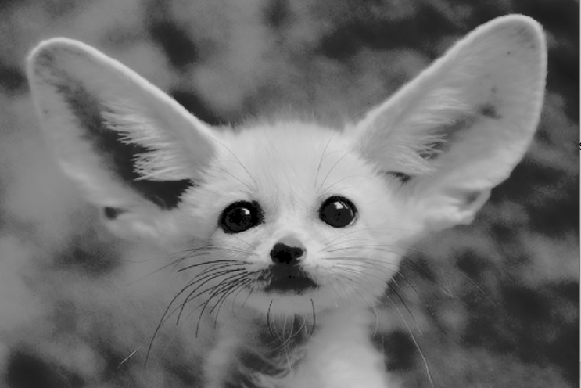

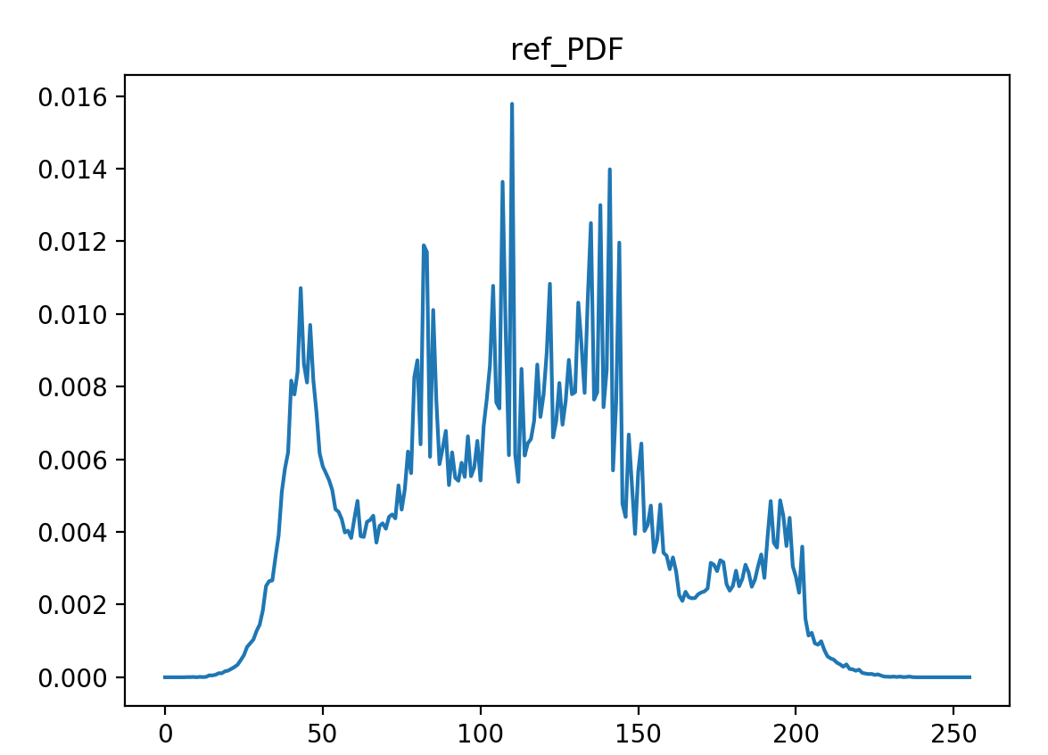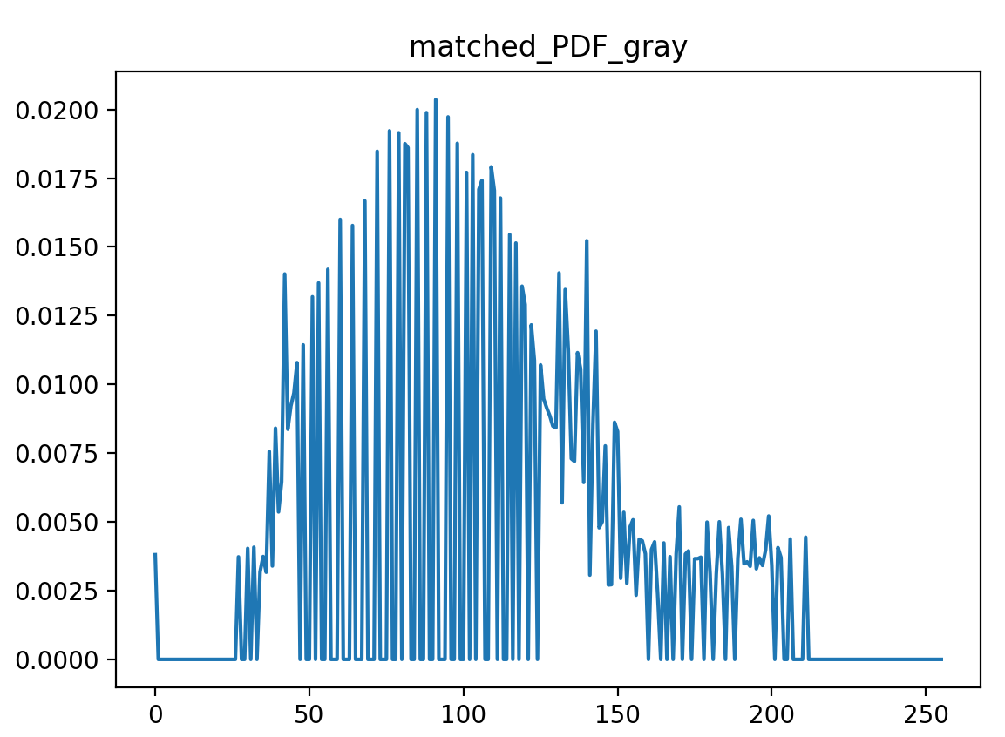

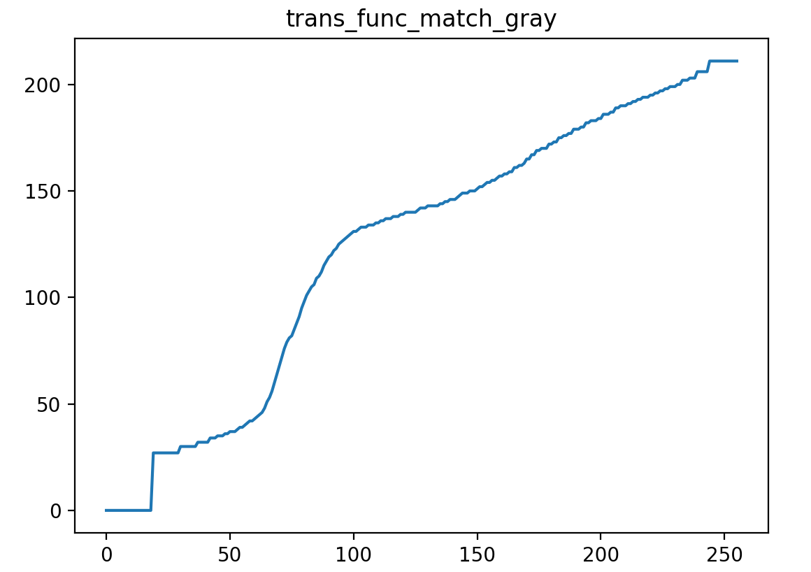

**2) RGB**

**A. Code**

#include "hist_func.h"

#include <iostream>

using namespace std;

void hist_eq(Mat &input, Mat &equalized, G *trans_func, float *CDF);

void func_inverse(G *trans_func, G *inverse_func);

int main() {

/*

Input: Original Image, Reference Image

Output:

-histogram-matched image

-1 transfer function(txt file)

-1 histogram of the original image(txt file)

-1 histogram of the ouput image(txt file)

*/

Mat input = imread("input.jpg", CV_LOAD_IMAGE_COLOR);

Mat input_matched_YUV;

Mat ref = imread("ref.jpg", CV_LOAD_IMAGE_COLOR);

Mat ref_matched_YUV;

//1. Convert the color image RGB to YUV

cvtColor(input, input_matched_YUV, CV_RGB2YUV);

cvtColor(ref, ref_matched_YUV, CV_RGB2YUV);

//Split each channel(Y, U, V);

Mat input_channels[3]; Mat ref_channels[3];

split(input_matched_YUV, input_channels); split(ref_matched_YUV, ref_channels);

Mat input_Y = input_channels[0]; Mat ref_Y = ref_channels[0];

//PDF or transfer function txt files

FILE *f_PDF_R, *f_PDF_G, *f_PDF_B;

FILE *f_matched_PDF_R, *f_matched_PDF_G, *f_matched_PDF_B;

FILE *f_trans_func_match_YUV;

fopen_s(&f_PDF_R, "PDF_R(match).txt", "w+"); fopen_s(&f_PDF_G, "PDF_G(match).txt", "w+"); fopen_s(&f_PDF_B, "PDF_B(match).txt", "w+");

fopen_s(&f_matched_PDF_R, "matched_PDF_R.txt", "w+"); fopen_s(&f_matched_PDF_G, "matched_PDF_G.txt", "w+"); fopen_s(&f_matched_PDF_B, "matched_PDF_B.txt", "w+");

fopen_s(&f_trans_func_match_YUV, "trans_func_match_YUV.txt", "w+");

// 2. Apply the histogram matching for Y channel only

// Compute the transfer functions s = T(r) for histogram equalization of input's Y channel, and perform histogram equalization

float **PDF_input_RGB = cal_PDF_RGB(input);

float *CDF_input_YUV = cal_CDF(input_Y);

G Tr_YUV[L] = { 0 }; //transfer function s = T(r)

hist_eq(input_Y, input_Y, Tr_YUV, CDF_input_YUV);

// Compute the transfer functions s = G(z) for histogram equalization of ref's Y channel

//float **PDF_ref_RGB = cal_PDF_RGB(ref);

float *CDF_ref_YUV = cal_CDF(ref_Y);

G Gz_YUV[L] = { 0 }; //transfer function s = T(r)

hist_eq(ref_Y, ref_Y, Gz_YUV, CDF_ref_YUV);

// Apply the intensity mapping from r to z

G inverseGz[L] = { 0 };

func_inverse(Gz_YUV, inverseGz);

// perform the transfer function

for (int i = 0; i < input.rows; i++)

for (int j = 0; j < input.cols; j++)

input_Y.at<G>(i, j) = inverseGz[Tr_YUV[input_Y.at<G>(i, j)]];

//3. Convert the histogram-matched Y and UV to the color image(RGB)

// merge Y. U, V channels

merge(input_channels, 3, input_matched_YUV);

// YUV -> RGB

cvtColor(input_matched_YUV, input_matched_YUV, CV_YUV2RGB);

// output PDF

float **PDF_output_RGB = cal_PDF_RGB(input_matched_YUV);

//write files

for (int i = 0; i < L; i++) {

// write PDF of original image

fprintf(f_PDF_R, "%d\t%f\n", i, PDF_input_RGB[i][0]); fprintf(f_PDF_G, "%d\t%f\n", i, PDF_input_RGB[i][1]); fprintf(f_PDF_B, "%d\t%f\n", i, PDF_input_RGB[i][2]);

// write PDF of output image

fprintf(f_matched_PDF_R, "%d\t%f\n", i, PDF_output_RGB[i][0]); fprintf(f_matched_PDF_G, "%d\t%f\n", i, PDF_output_RGB[i][1]); fprintf(f_matched_PDF_B, "%d\t%f\n", i, PDF_output_RGB[i][2]);

// write transfer functions

fprintf(f_trans_func_match_YUV, "%d\t%d\n", i, inverseGz[Tr_YUV[i]]);

}

//file close

fclose(f_PDF_R); fclose(f_PDF_G); fclose(f_PDF_B);

fclose(f_matched_PDF_R); fclose(f_matched_PDF_G); fclose(f_matched_PDF_B);

fclose(f_trans_func_match_YUV);

////////////////////// Show each image ///////////////////////

namedWindow("RGB", WINDOW_AUTOSIZE);

imshow("RGB", input);

namedWindow("Equalized_YUV", WINDOW_AUTOSIZE);

imshow("Equalized_YUV", input_matched_YUV);

//////////////////////////////////////////////////////////////

waitKey(0);

return 0;

}

// histogram equalization

void hist_eq(Mat &input, Mat &equalized, G *trans_func, float *CDF) {

// compute transfer function

for (int i = 0; i < L; i++)

trans_func[i] = (G)((L - 1) * CDF[i]);

// perform the transfer function

for (int i = 0; i < input.rows; i++)

for (int j = 0; j < input.cols; j++)

equalized.at<G>(i, j) = trans_func[input.at<G>(i, j)];

}

//get inverse function G-1

void func_inverse(G *trans_func, G *inverse_func) {

/* Return z = G-1(s) */

bool checked[L] = { 0 };

for (int i = 0; i < L; i++) {

if (checked[trans_func[i]])

continue;

inverse_func[trans_func[i]] = (G)i;

checked[trans_func[i]] = 1;

}

for (int i = 0; i < L; i++)

if (!checked[i])

inverse_func[i] = (G)inverse_func[i - 1];

}

**B. Result**

-Original Image / Histogram

3-2)-B와 동일

-Output image / Histogram

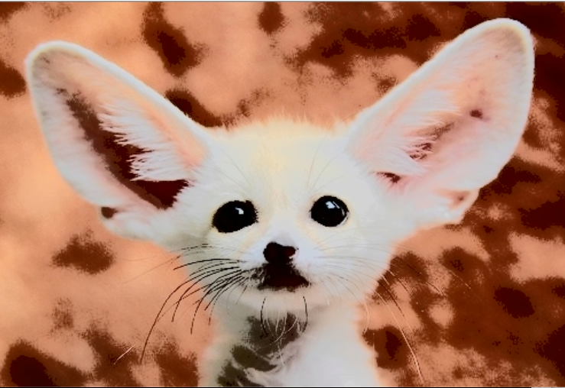



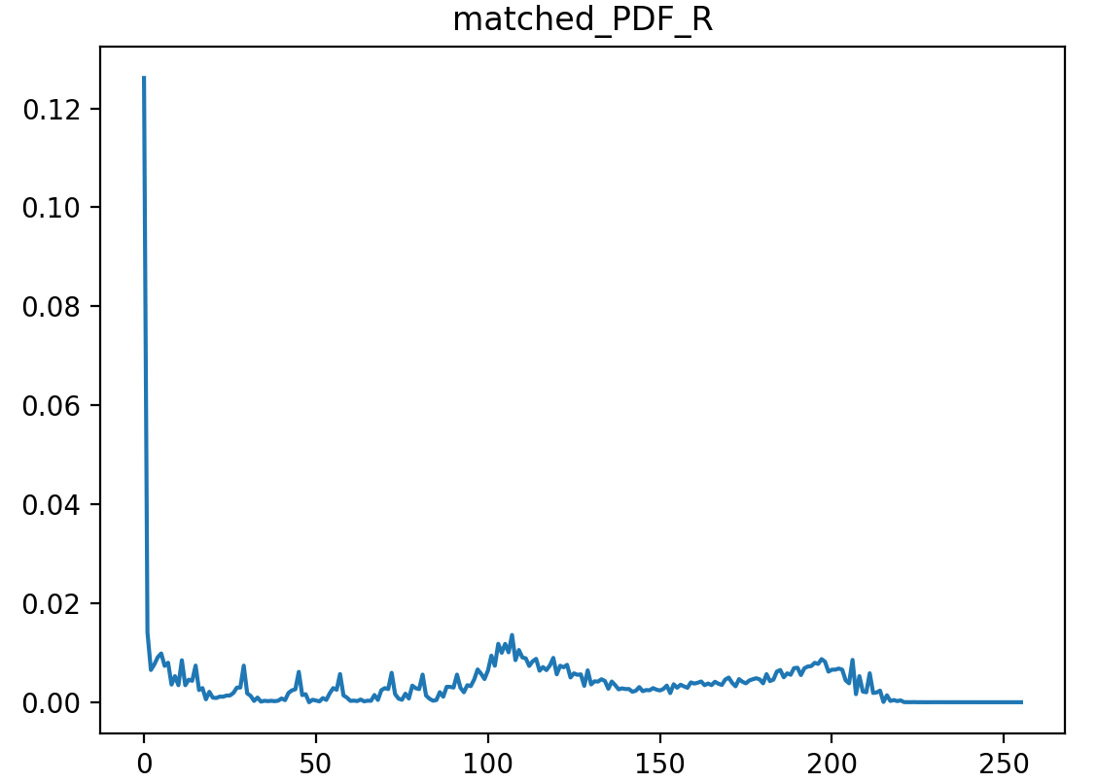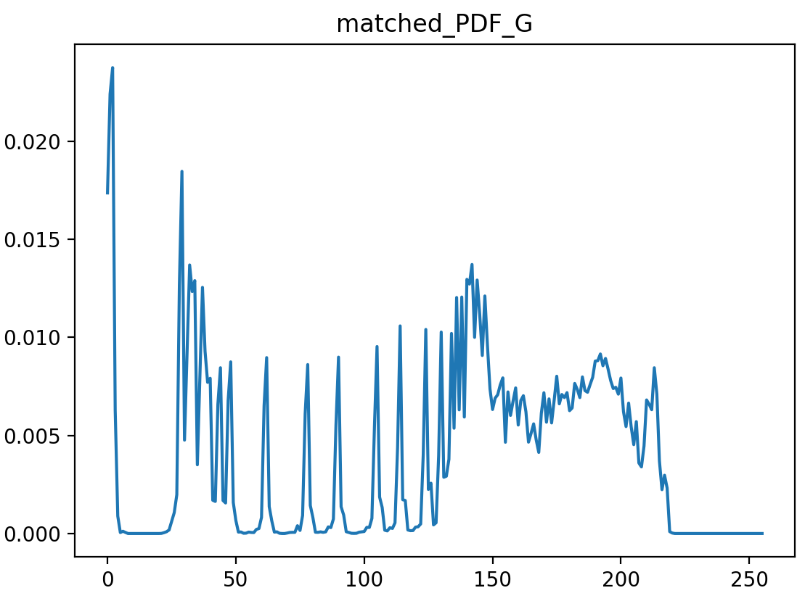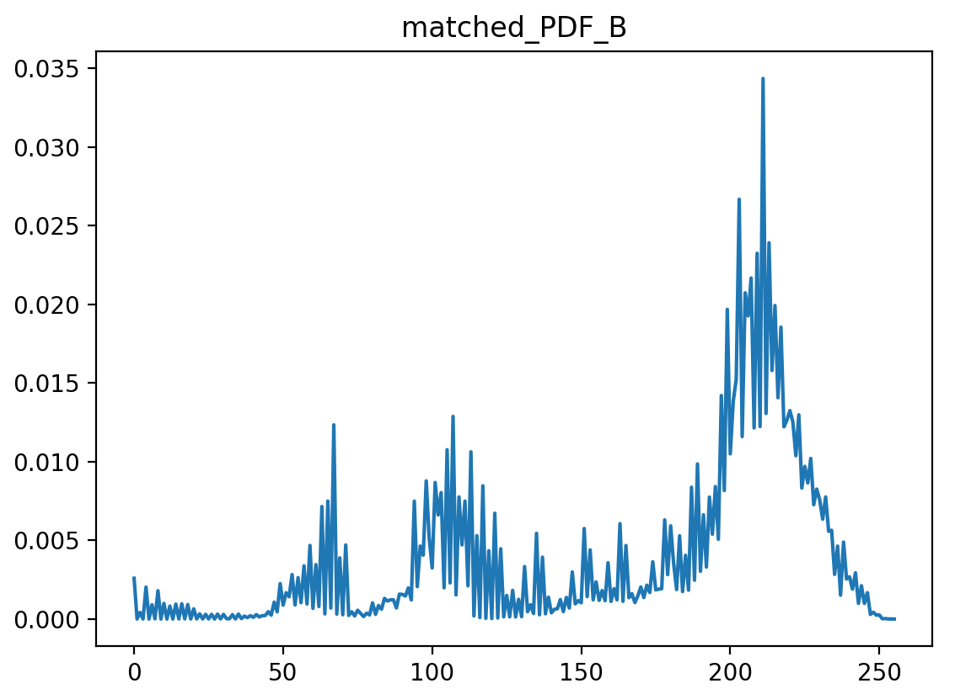

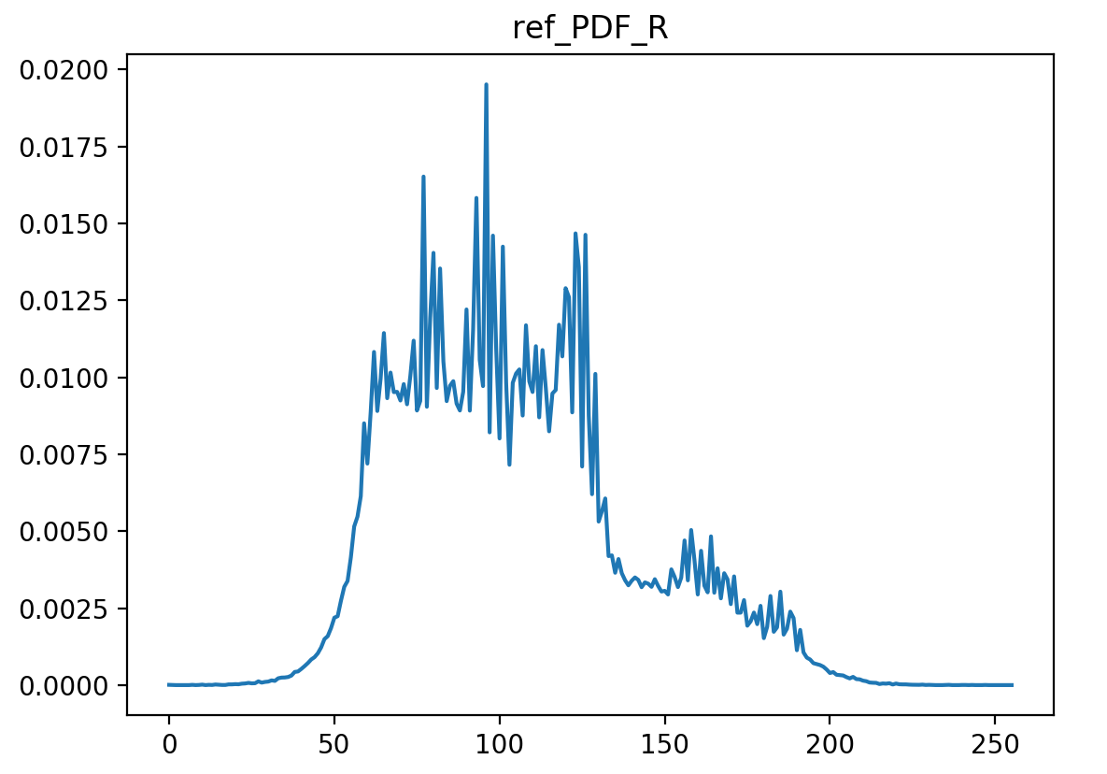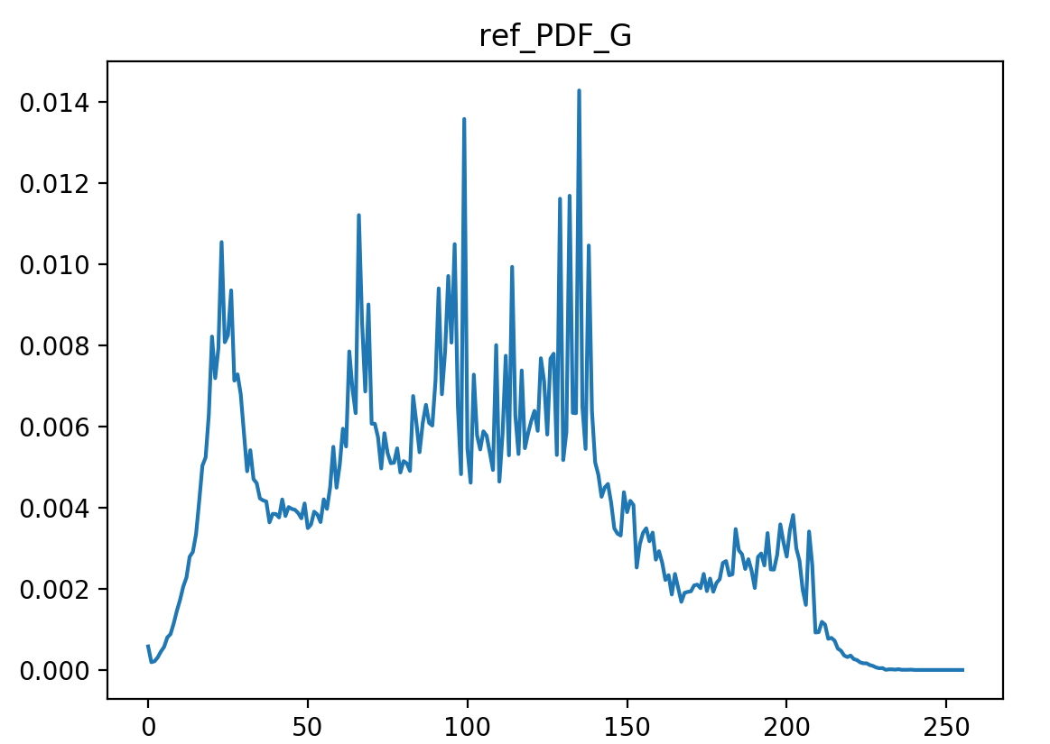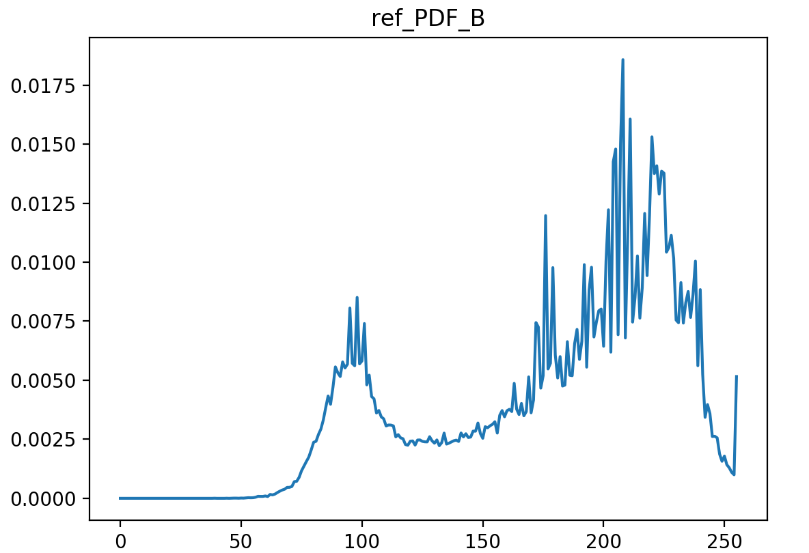

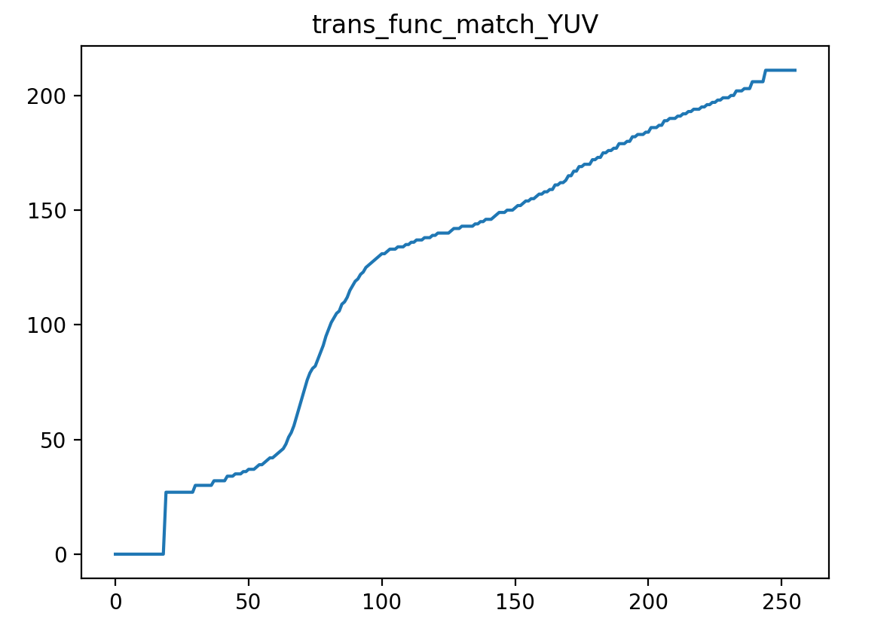

**\*Code for drawing plot**

import matplotlib.pyplot as plt  
  
def getPlot(dir):  
 x_axis = [i for i in range(256)]  
 y_axis = []  
 file = open(dir, 'r')  
 while True:  
 line = file.readline()  
 if not line:  
 break  
 _, y = map(float, line.split())  
 y_axis.append(y)  
  
 file.close()  
  
 plt.plot(x_axis, y_axis)  
 plt.title(dir[:-4])  
 #plt.legend()  
 plt.show()